**Create New Collector Map for New Drainage**

1. Log in to arcgis.com
2. Open the “Content” section
3. On the left you select “New item” 
4. New item type, you select “Feature layer” 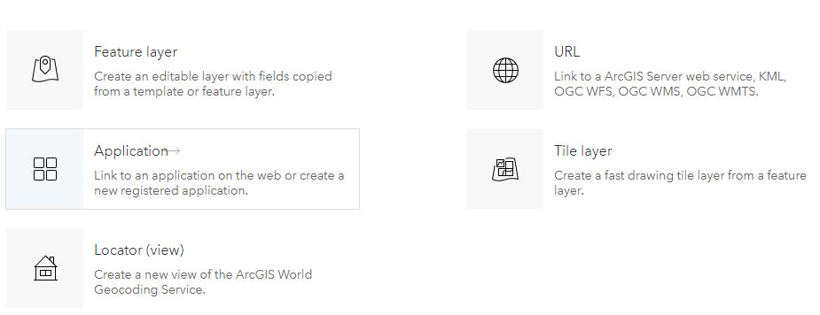
5. Go to the “From Existing Layer” tab. 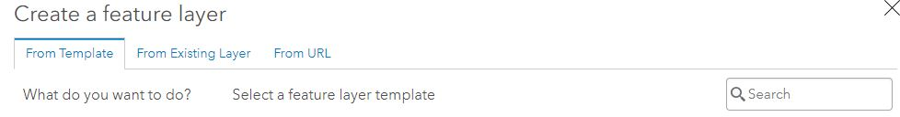
6. Search – “DASH” 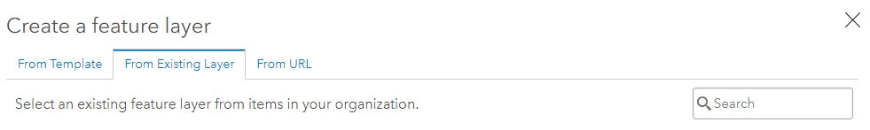
7. Select DASH_CU_Points_Template_V1

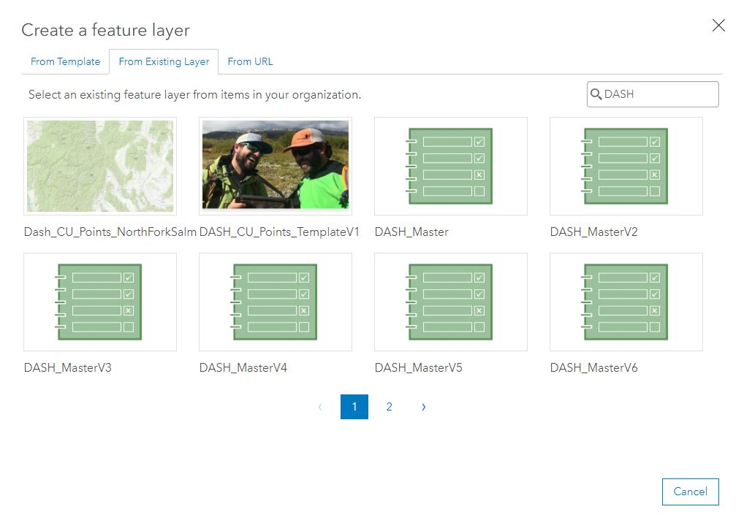

1. Choose “Create”

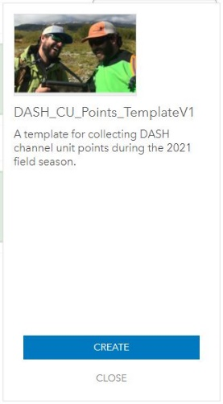

1. Click on “DASH_CU_Points”, it will open the text field. Change the name to reflect the drainage to be sampled. Example- DASH_CU_Points_NorthForkSalmon21. It is important to change this name to avoid conflicts with other layers.

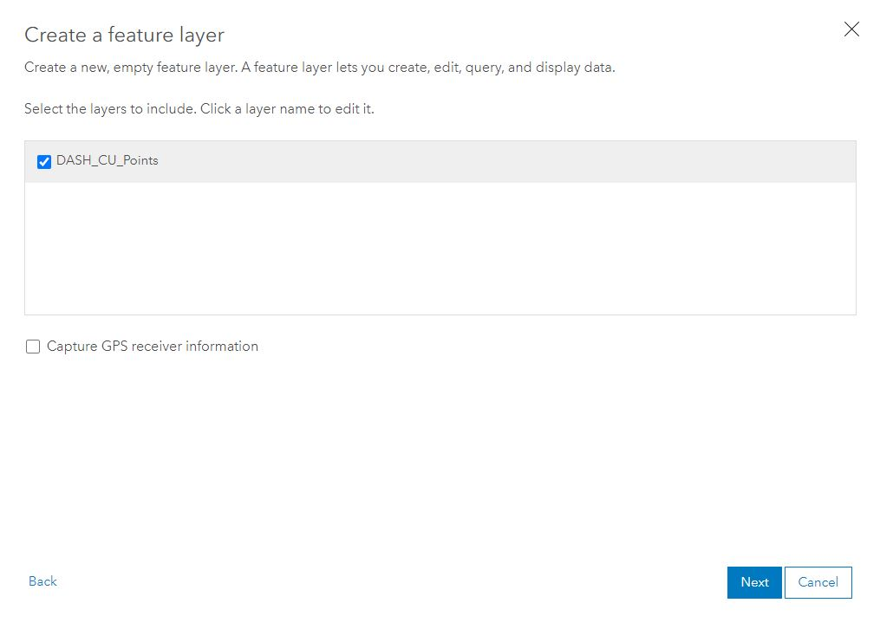

1. Zoom in to a wide extent you wish the layer to encompass. This doesn’t matter a whole lot because you download offline maps that are transect/day specific so for this full extent zooming into have most of the state including the sample area is sufficient. 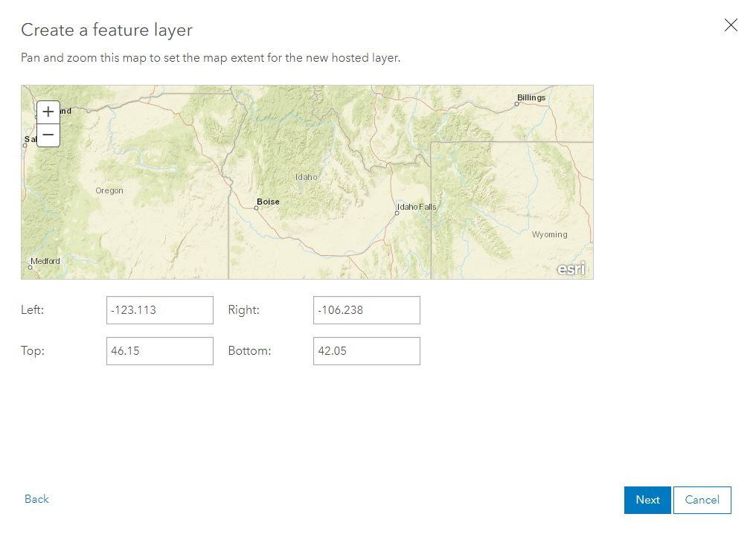

Select Next.

1. Title the web map layer.  
   Select the folder to save within. *There should be an individual folder for each sample drainage/year.  
   Select done to finish.

